Press Release to the Cape Gazette – 10/17/2022

Cape Henlopen State Park Beach Cleanup Event

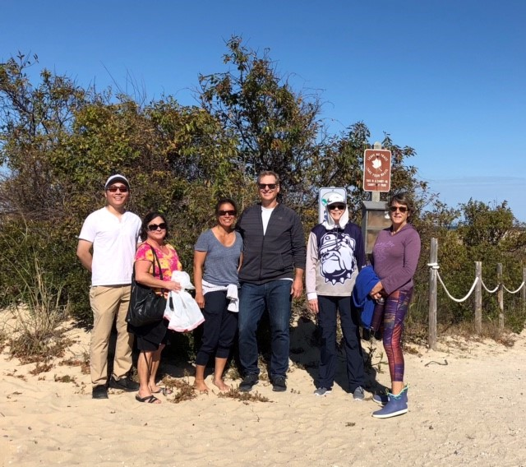
Participants (left to right): Qi Li, Beth Maskell, Jennie Reisner, Paul Reisner, Kathi Colman, and Tina Downs
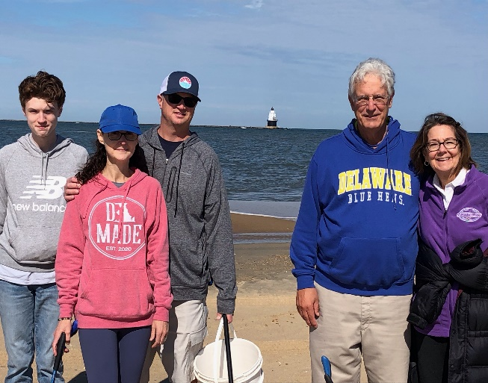
Participants (left to right): Finn Carroll, Erin Carroll, Joe Carroll, Ray Tomasetti, and Chris Tomasetti

On Sunday, October 16, 2022, The Villages of Five Points Community Enhancement Foundation, with assistance from staff from Delaware State Parks, sponsored a beach cleanup event along the ocean side of The Point at Cape Henlopen State Park. The Foundation through the DNREC “Adopt-a-Beach” program adopted a portion of The Point beach and plans to hold two cleanup events annually. Volunteers from The Villages of Five Points community spent part of the beautiful Sunday afternoon walking the beach, admiring the Harbor of Refuge Lighthouse, and collecting trash.

The Villages of Five Points Community Enhancement Foundation, Inc. is a 501(c)(3) public charity founded in 2019 to promote the preservation of open space, environmental conservation, and enhance the surrounding community and roadsides.

